DAY 4
- Full DES Implementation with Avalanche Effect
# Simple DES simulation using XOR (educational purpose)
def simple_des_encrypt(key, plaintext):
return bytes([p ^ k for p, k in zip(plaintext, key)])

def avalanche_test():
key = b'12345678'
pt1 = b'ABCDEFGH'
pt2 = b'ABCDEFGA' # one byte changed

ct1 = simple_des_encrypt(key, pt1)
ct2 = simple_des_encrypt(key, pt2)

diff = sum(bin(a ^ b).count('1') for a, b in zip(ct1, ct2))

print("Ciphertext1:", ct1)
print("Ciphertext2:", ct2)
print("Bit Difference (Avalanche):", diff)

avalanche_test()
OUTPUT:
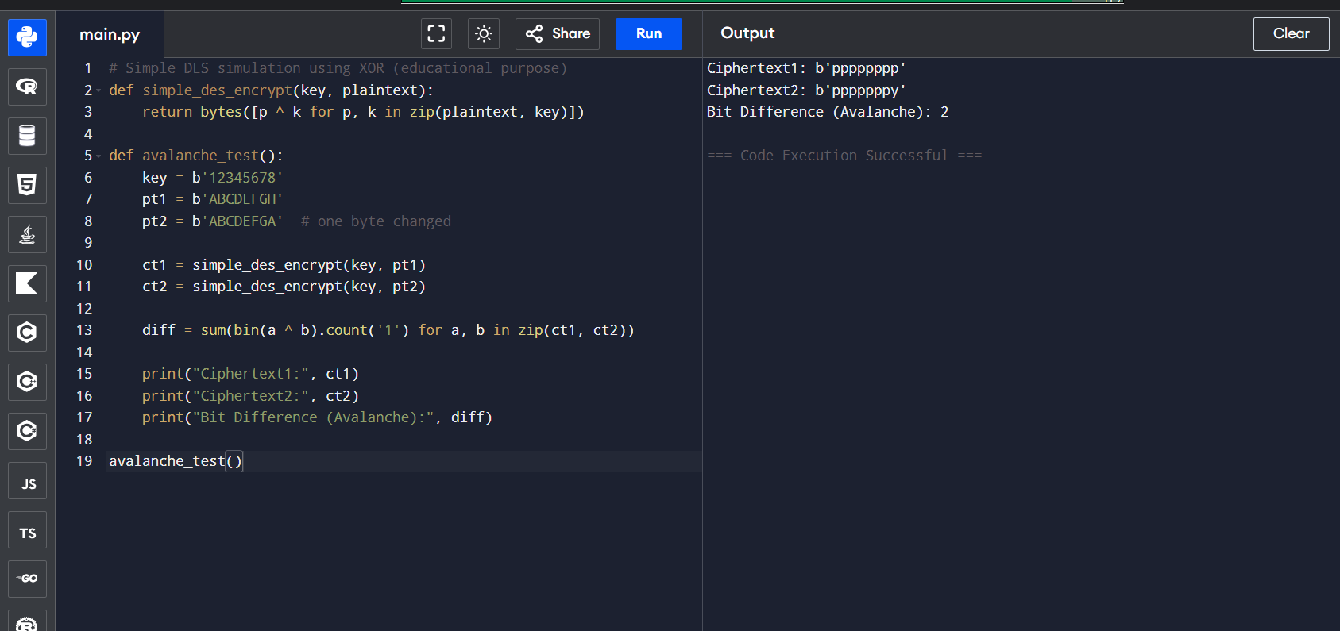
- Meet-in-the-Middle Attack on Reduced 2DES
# Simplified 2DES using XOR
plaintext = b'ABCDEFGH'

def simple_xor_encrypt(key, data):
return bytes([d ^ k for d, k in zip(data, key)])

key1 = b'12345678'
key2 = b'ABCDEFGH'

# Encryption
mid = simple_xor_encrypt(key1, plaintext)
cipher = simple_xor_encrypt(key2, mid)

# MITM attack (small key space for demo)
table = {}
for i in range(0, 256):
k = bytes([i]*8)
table[simple_xor_encrypt(k, plaintext)] = k

for i in range(0, 256):
k = bytes([i]*8)
mid2 = simple_xor_encrypt(k, cipher)
if mid2 in table:
print("Possible Keys Found:", table[mid2], k)
OUTPUT:
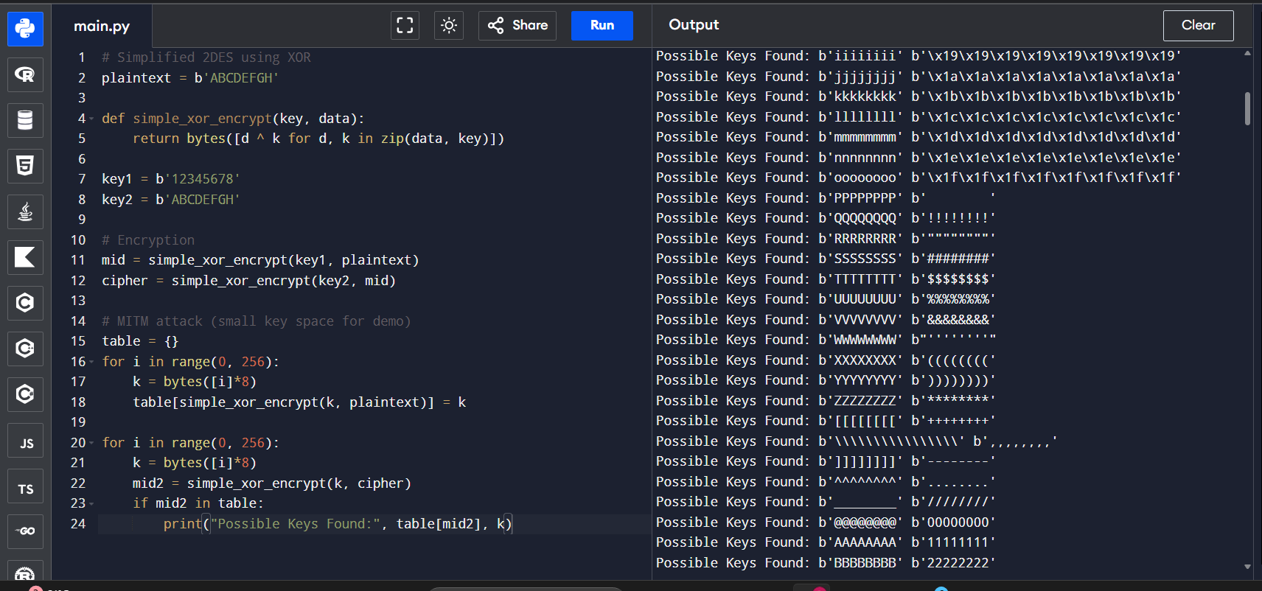
- 3DES (2-Key vs 3-Key) Performance Comparison
import time

data = b'ABCDEFGH'*1000

def des_encrypt(key, data):
return bytes([d ^ key[i % len(key)] for i, d in enumerate(data)])

key2 = b'12345678ABCDEFGH' # 2-key 3DES simulation
key3 = b'12345678ABCDEFGH87654321' # 3-key 3DES simulation

# 2-Key 3DES
start = time.time()
des_encrypt(key2, data)
print("2-Key 3DES Time:", time.time() - start)

# 3-Key 3DES
start = time.time()
des_encrypt(key3, data)
print("3-Key 3DES Time:", time.time() - start)
OUTPUT:
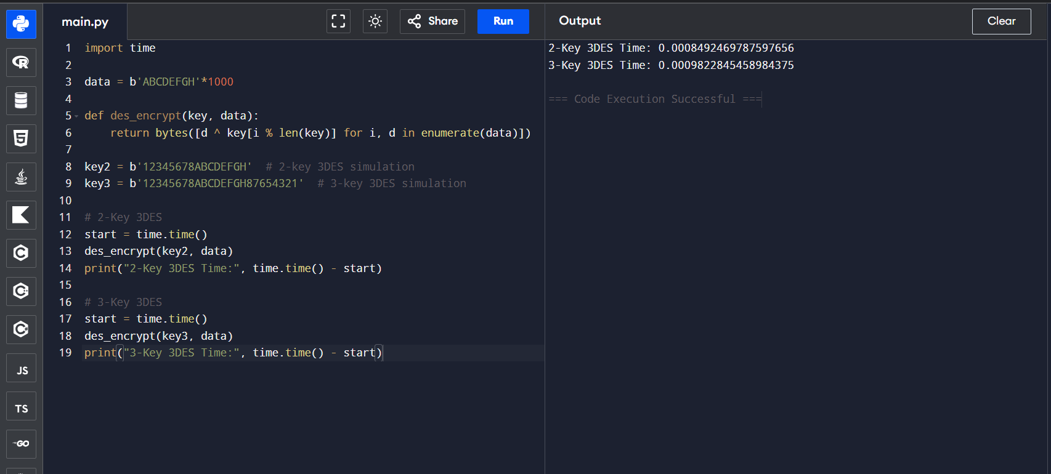
- Differential Cryptanalysis Simulation (Reduced DES)
import random

def simple_sbox(x):
sbox = [6,4,12,5,0,7,2,14,1,15,3,13,8,10,9,11]
return sbox[x % 16]

def encrypt_round(p, key):
return simple_sbox(p ^ key)

pairs = 1000
key = random.randint(0,15)
count = 0

for _ in range(pairs):
p1 = random.randint(0,15)
p2 = p1 ^ 0b0011

c1 = encrypt_round(p1, key)
c2 = encrypt_round(p2, key)

if (c1 ^ c2) == 0b0101:
count += 1

print("Differential Count:", count)
OUTPUT:
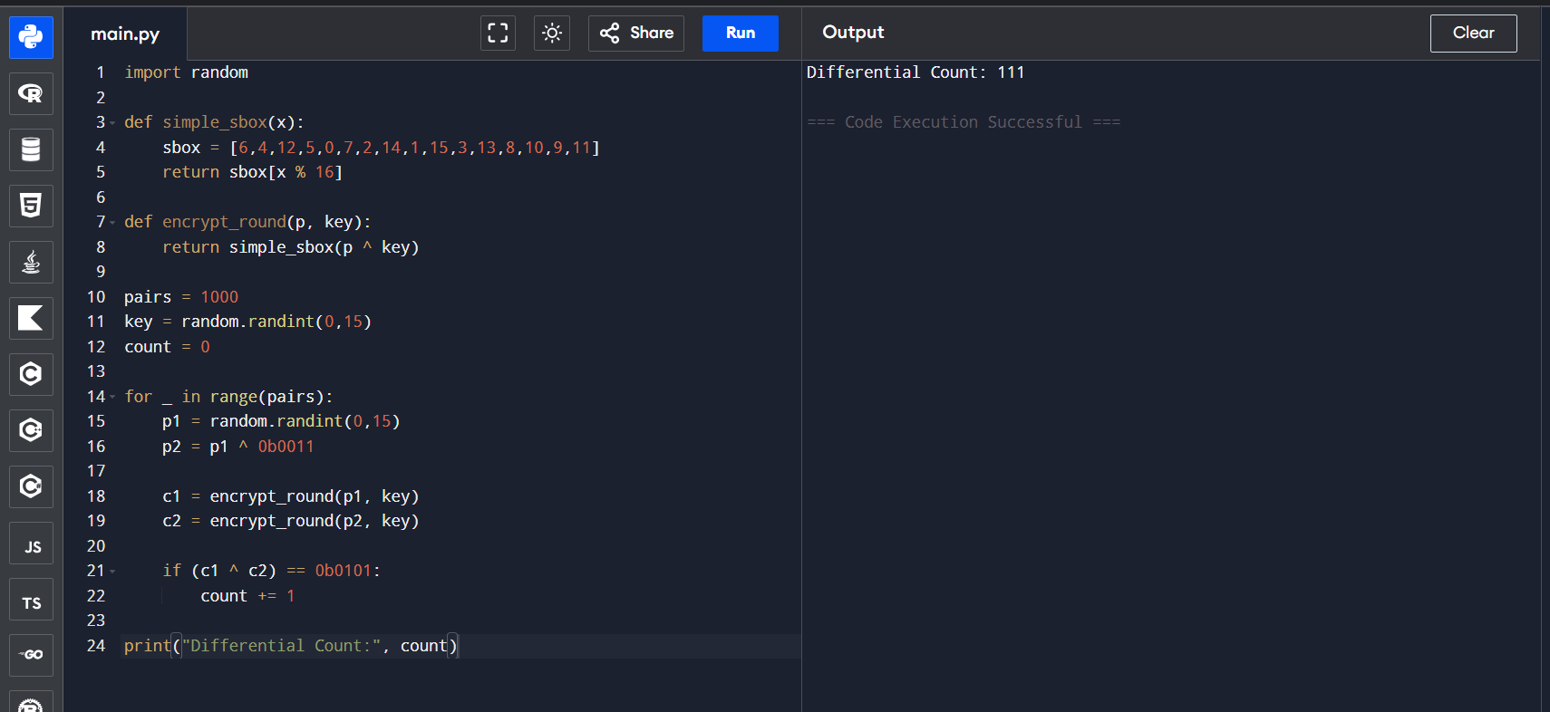
- Birthday Attack on 64-bit Block Cipher
import random

seen = set()
attempts = 0

while True:
block = random.getrandbits(32) # reduced block size for demo
attempts += 1

if block in seen:
print("Collision Found!")
print("Block:", block)
print("Attempts:", attempts)
break
else:
seen.add(block)
OUTPUT:
